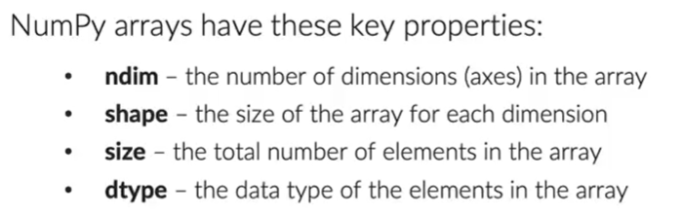

























argmax / argmin return the index of the max / min values in an array













